

ELEMENTARY SCHOOL BOUNDARY MAP
MAPA DE LÍMITES DE LA ESCUELA PRIMARIA
Child Welfare and Attendance Office
599 Fifth Street · McFarland, CA 93250
Telephone: (661) 792-3178 · Fax (661) 792-6758

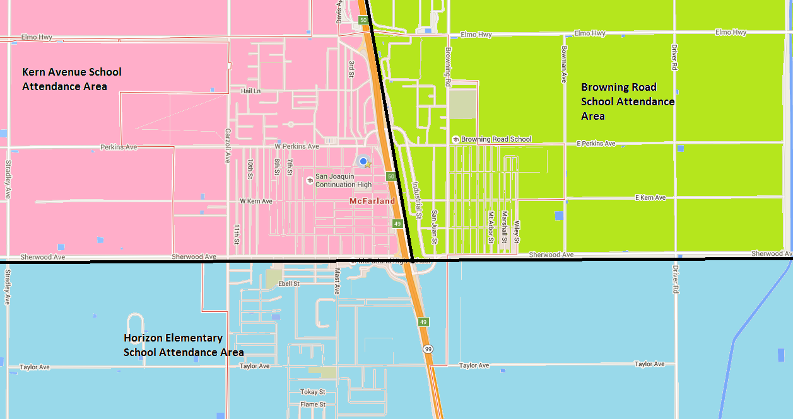
Boundary/Límite:
Sherwood Avenue – South
Boundary/Límite:
East Sherwood Avenue – North
Highway 99 - East
Boundary/Límite:
West Sherwood Avenue – North
Highway 99 - West

